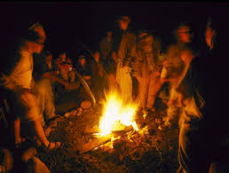
Come celebrate
On Saturday 30th July 2016

Banyule District Cubs are having a Campfire where we will celebrate 100 years of Cub Scouts
At 8.00pm AEST there will be a co-ordinated reaffirming of the Cub Scout Promise & Law throughout Australia
Location:
2nd Ivanhoe Scout Hall
Wallace St
Ivanhoe
Start time 7.00
Finish 9.00
When dropping off and pickup:
Please use the Coles Supermarket for parking and walk approximately 300 meters to
the 2nd Ivanhoe Hall.
A Gold coin donation is payable on the night and this will go to a local charity
All Packs should do one combined song & then a skit if time permits.
We require numbers by 26th July.
Please advise your Akela if you can/cannot attend
Look forward to seeing you on the night

